**ROBU VICTOR-DIMITRIE GRUPA:2131**

**ETAJ 1**

**Dimensionarea Etajului 1**

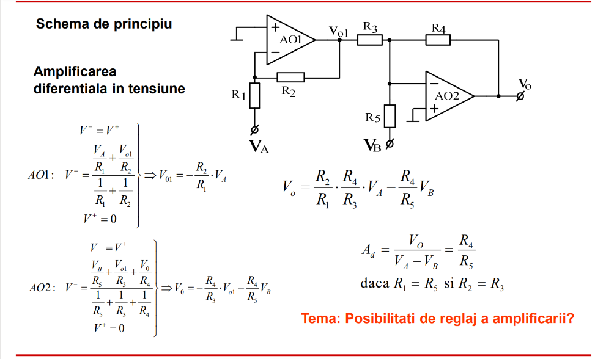

Av=10

Av=R4/R5=>R4=Av*R5=>R4=10*R5

**Alegem:** R4=10K ; R5=1K

R1=R5=1K

**Alegem:** R2=R3=5K

**DC/OP:**

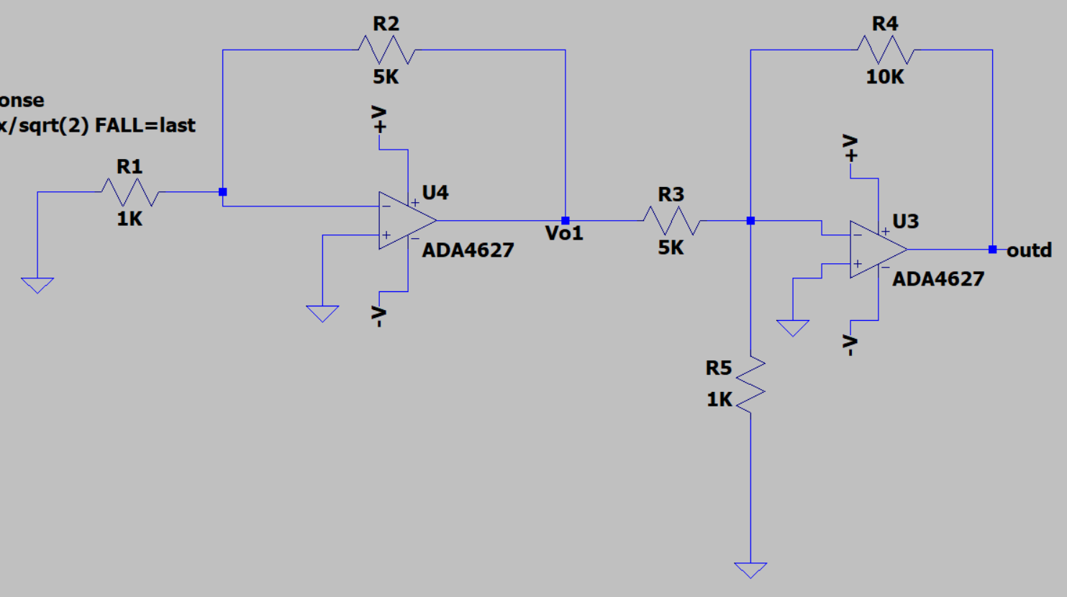

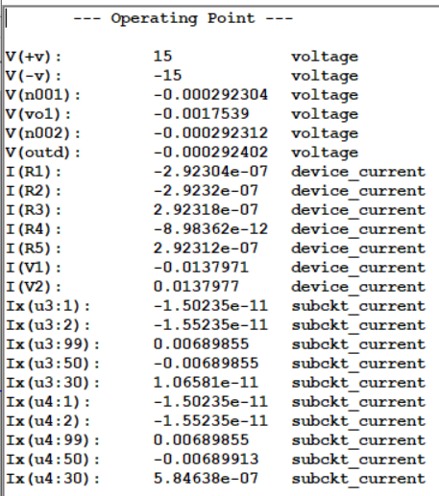

**AC:**

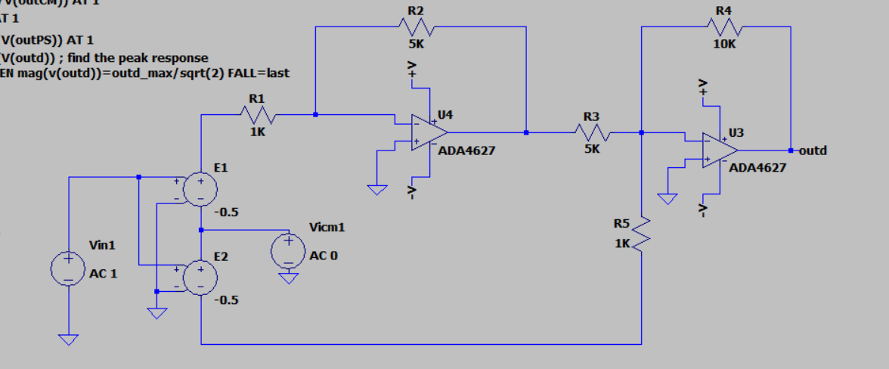

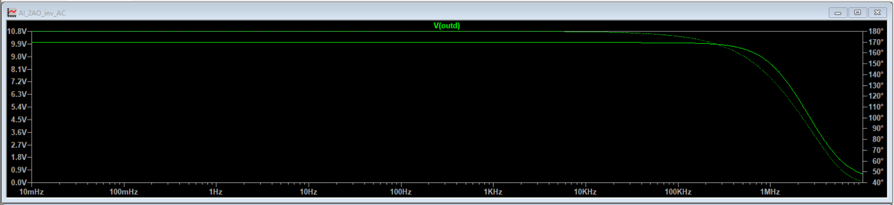

Av=10

Banda(La -3 db fata de maxim)=1.5488Mhz

Banda filtru=10K

=>Banda>Banda filtru

CMRR:

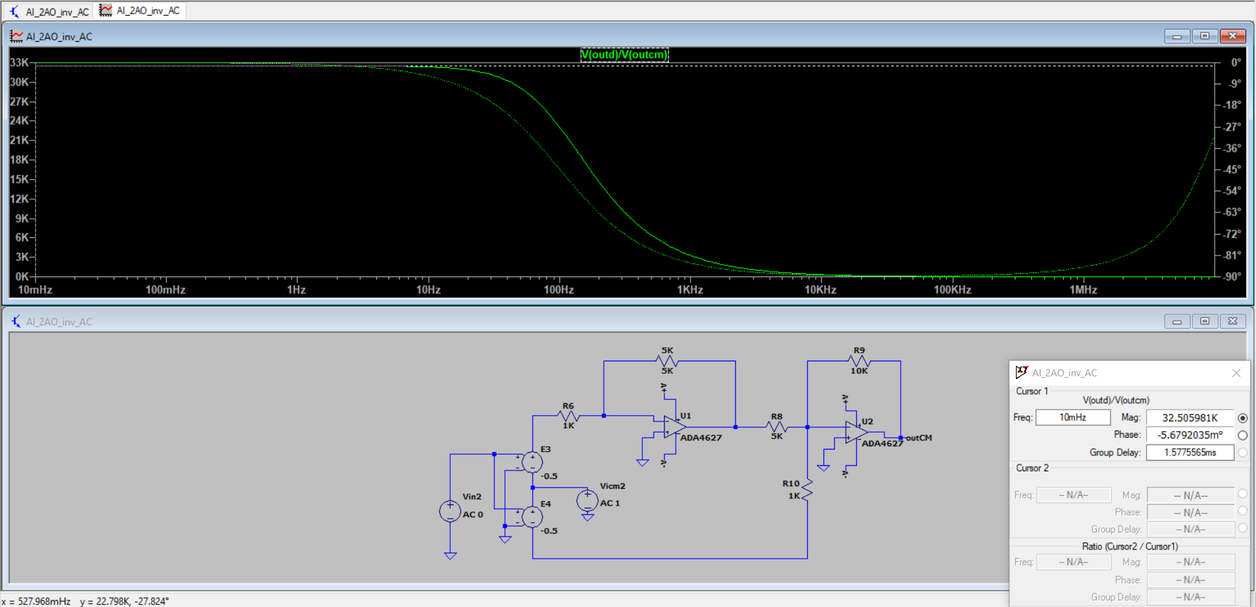

CMRR= Ad/Acm=32.50K

PSRR:

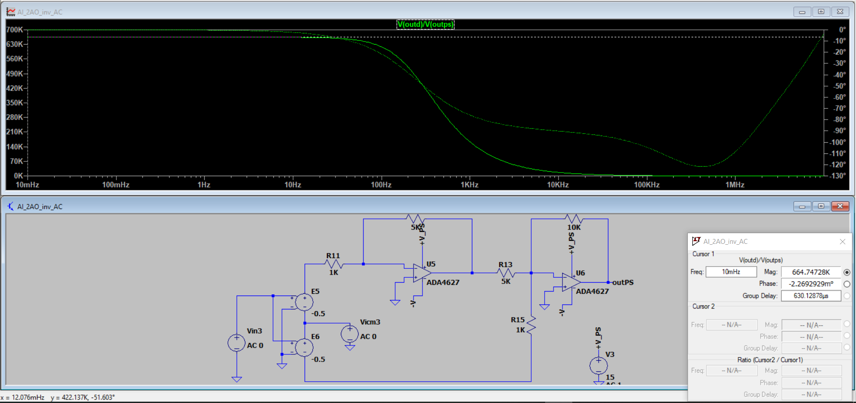

PSRR= Ad/Aps=664.74728K

**TRAN:**

Pentru Av=10 si Ain=12.5m => Aout= Av*Ain=125m

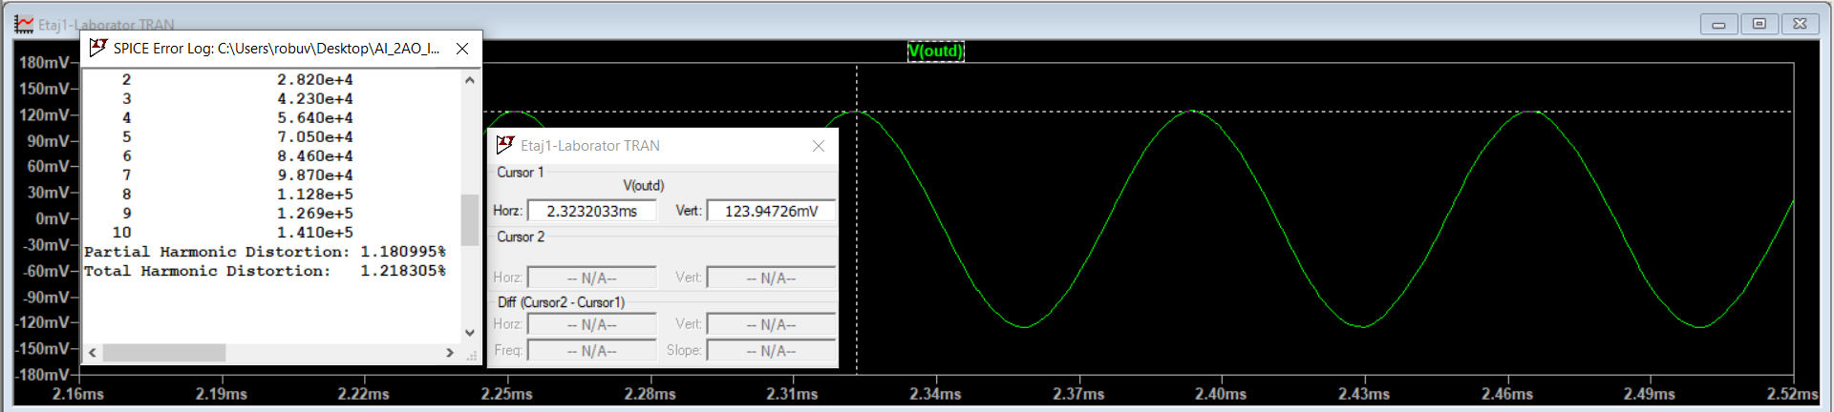

Pentru THD<1% am modificat amplitudinea de intrare cu 1m

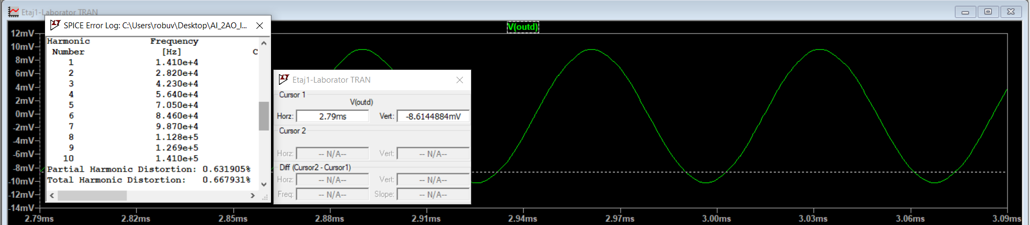

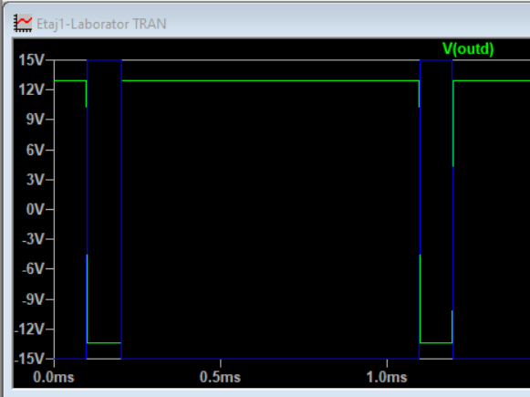

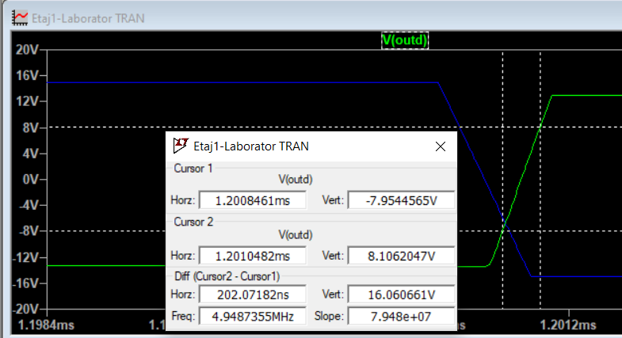

SR=16V/0.2us=80V/us

**Etajul 2**

**Dimensionarea Etajului 2:**

Q=1.41 > /3=> R1=R2=R3 si C1=C2=C

Bw=10KHz RC= $√2$/wo=15.9 u Alegem C=1nF =>R=15.9K

f=Bw*Q=14.1KHz Q=1.41=>K=3

W0=2 $π$ f=88.548Krad/s H0=3=>H0db=9.5dB R6=2R5=>Aleg: R5=1K R6=2K

**DC/OP:**

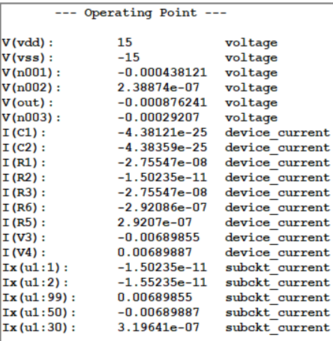

**AC:**

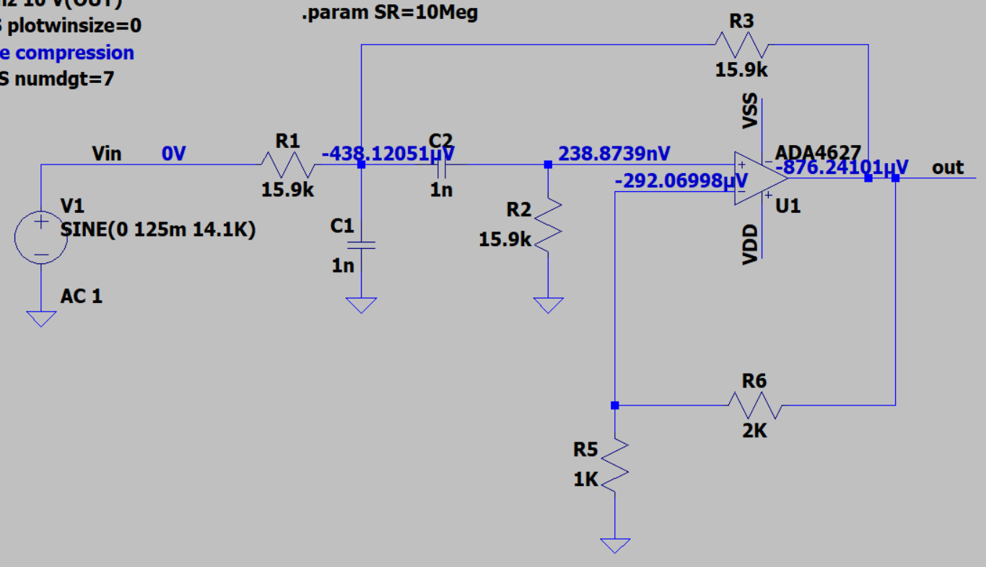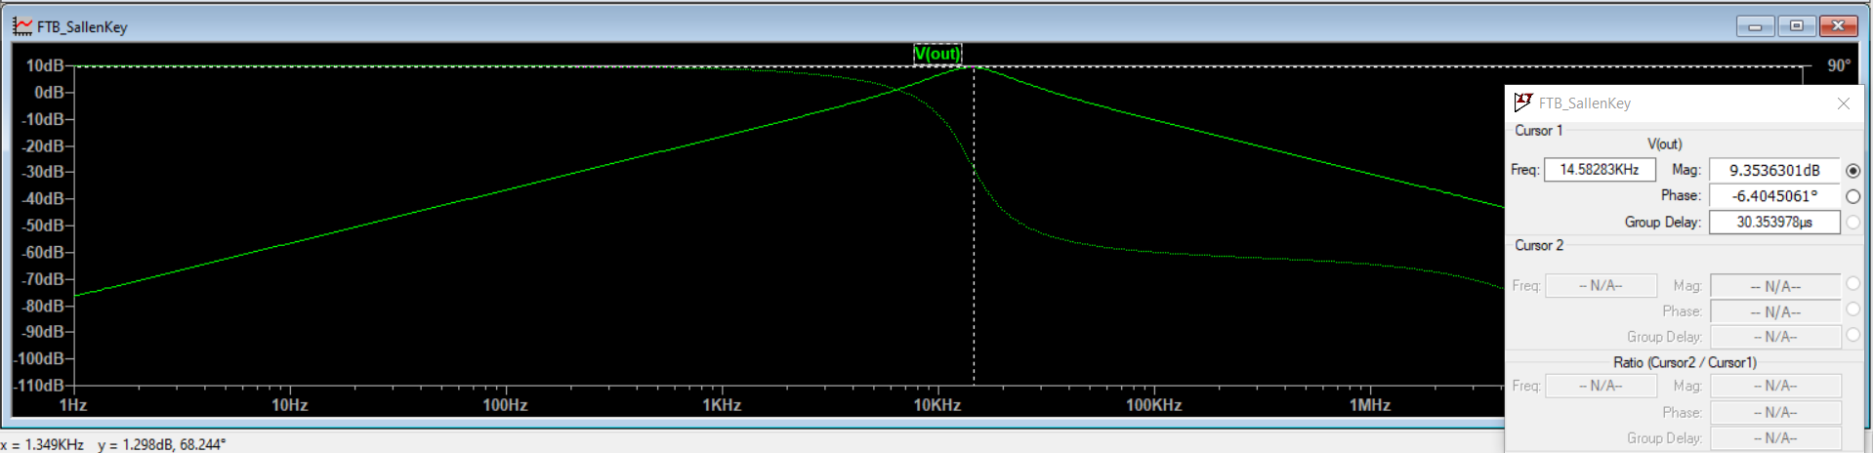

F0=14.58KHz

H0(db)=9.35

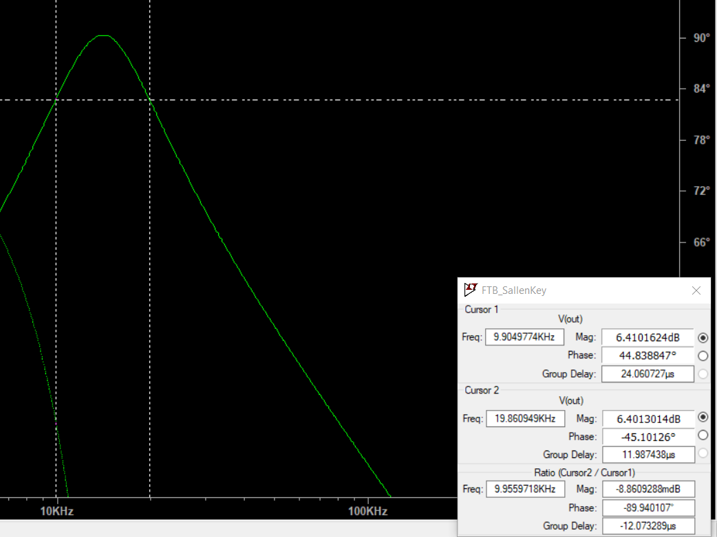

BW=9.99KHz

**Transient**

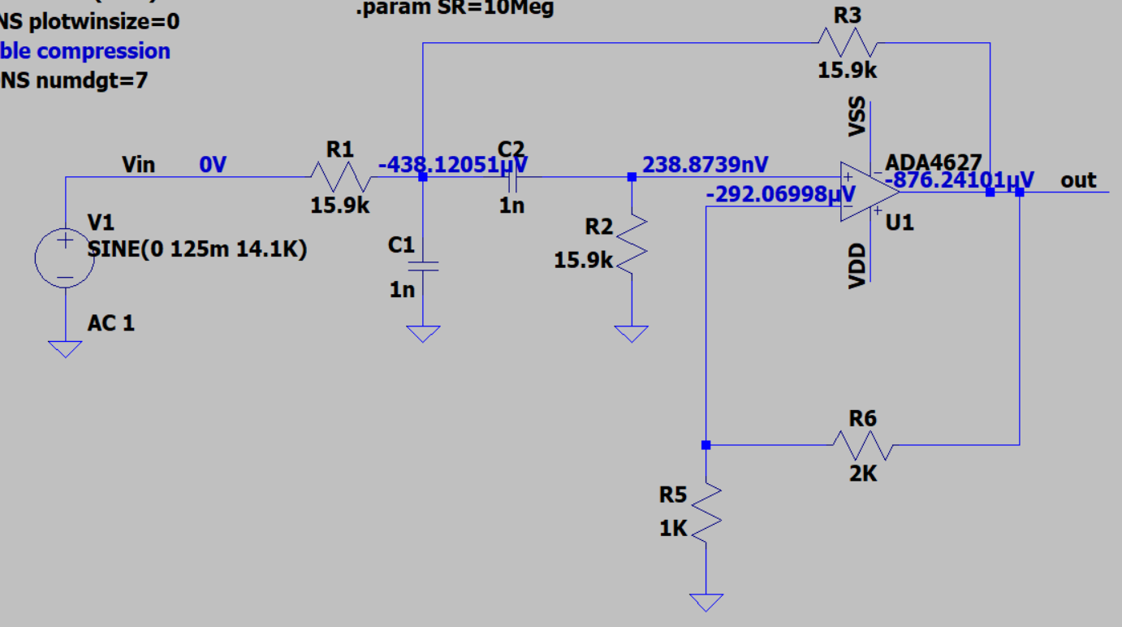

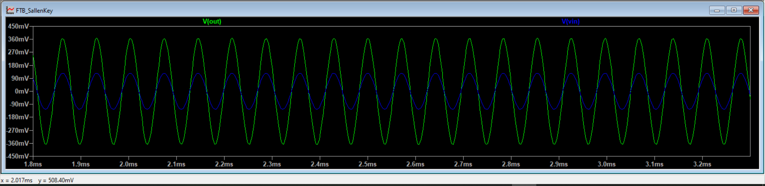

Avout=365mV

Avin=124mV => Avout=Ho*Avin

H0=3

Avout=3*124mV=>Avout=372mV

**Etaj 3**

**Dimensionarea Etajului 3:**

|  |  |  |  |  |  |  |  |
| --- | --- | --- | --- | --- | --- | --- | --- |
| **Sw1** | **Sw2** | **Sw3** | **Sw4** | **Sw5** | **Av** | **Adb** | **Alin** |
| **15** | **0** | **0** | **0** | **0** | **-R2/R1** | **12** | **4** |
| **0** | **15** | **0** | **0** | **0** | **-R3/R1** | **14** | **5** |
| **0** | **0** | **15** | **0** | **0** | **-R4/R1** | **16** | **6.31** |
| **0** | **0** | **0** | **15** | **0** | **-R5/R1** | **18** | **8** |
| **0** | **0** | **0** | **0** | **15** | **-R6/R1** | **20** | **10** |

Rin(min)=4K Alegem: R1=5K

R2/R1=4=>R2=20k

R3/R1=5=>R3=30k

R4/R1=6.31=>R3=31.5k

R5/R1=8=>R3=40k

R6/R1=10=>R3=50k

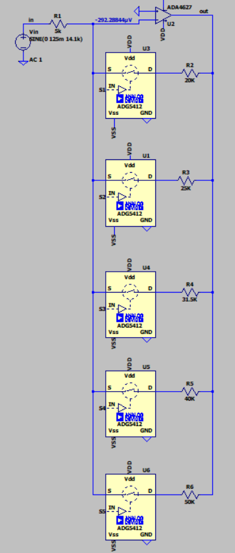

**DC/OP:**

SW1-on SW2-off SW3-off SW4-off SW5-off

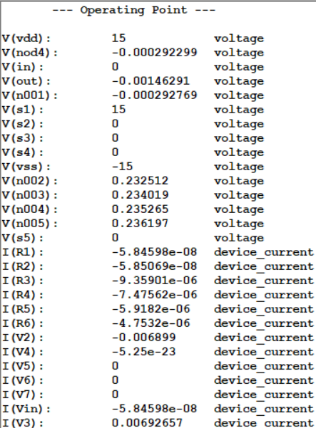

SW1-off SW2-on SW3-off SW4-off SW5-off

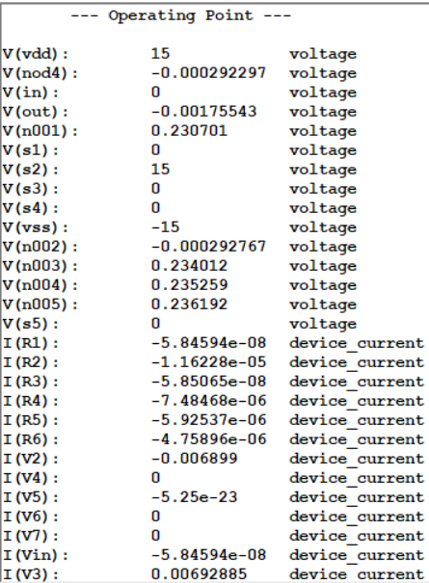

SW1-off SW2-off SW3-on SW4-off SW5-off

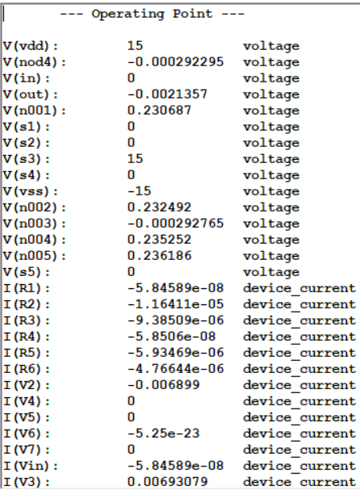

SW1-off SW2-off SW3-off SW4-on SW5-off

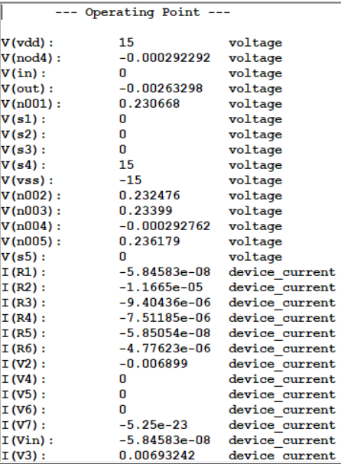

SW1-off SW2-off SW3-off SW4-off SW5-on

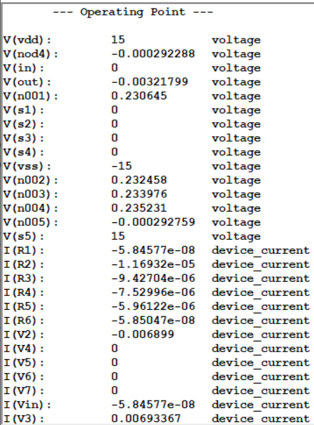

**AC:**

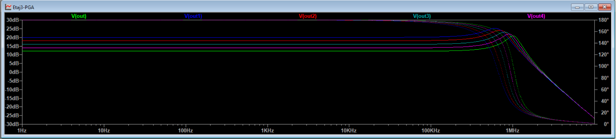

SW1=on

Calculam banda la 180-45=135(din cauza ca avem overshoot)

BW=870KHz Bwfiltru=10k => BW>Bwfiltru

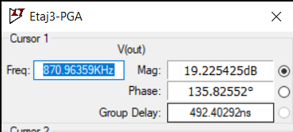

SW2=on

Calculam banda la 180-45=135(din cauza ca avem overshoot)

BW=769KHz Bwfiltru=10k => BW>Bwfiltru

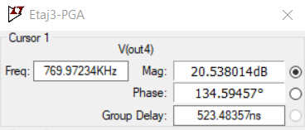

SW3=on

Calculam banda la 180-45=135(din cauza ca avem overshoot)

BW=664KHz Bwfiltru=10k => BW>Bwfiltru

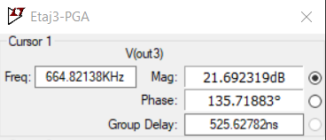

SW4=on

Calculam banda la 180-45=135(din cauza ca avem overshoot)

BW=575KHz Bwfiltru=10k => BW>Bwfiltru

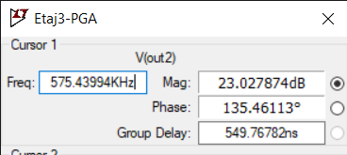

SW5=on

Calculam banda la 180-45=135(din cauza ca avem overshoot)

BW=501KHz Bwfiltru=10k => BW>Bwfiltru

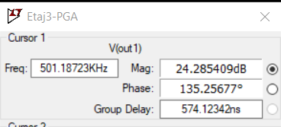

**Transient**

Pentru castig maxim PGA

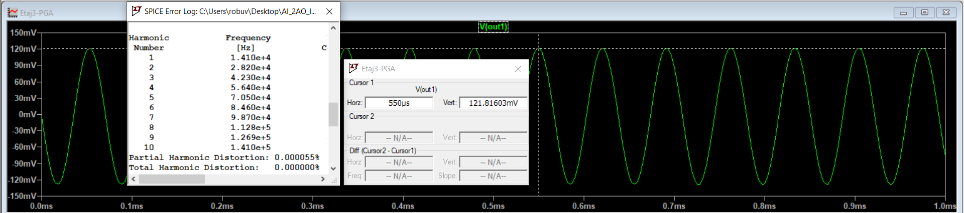

Pentru castig minim PGA

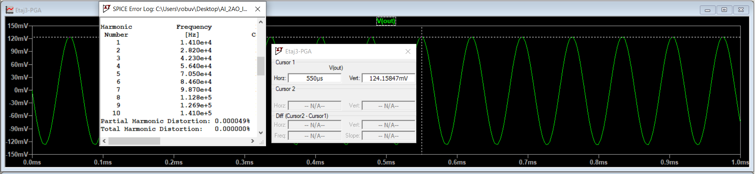

**Etaj 4**

**Dimensionarea Etajului 4:**

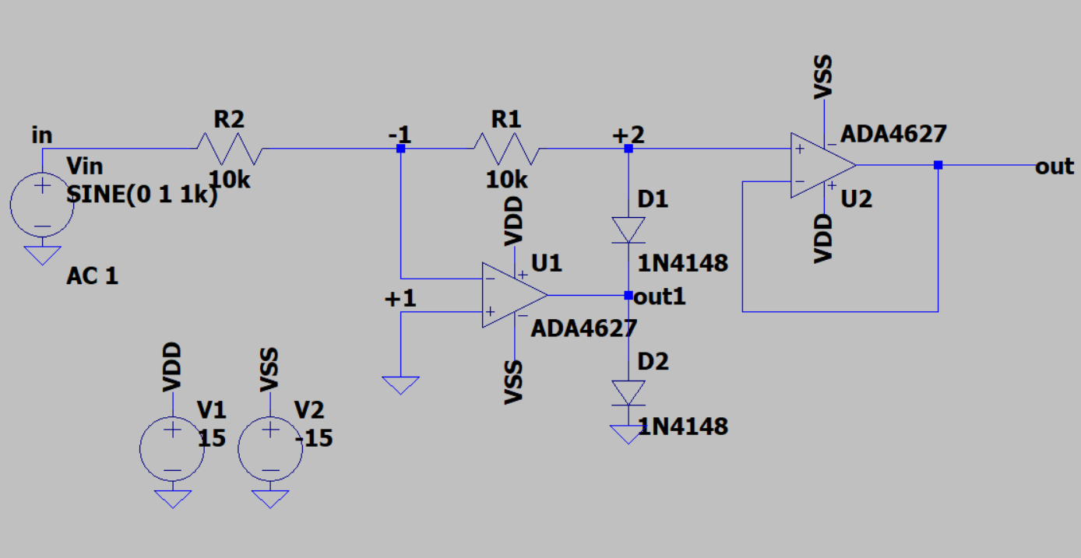

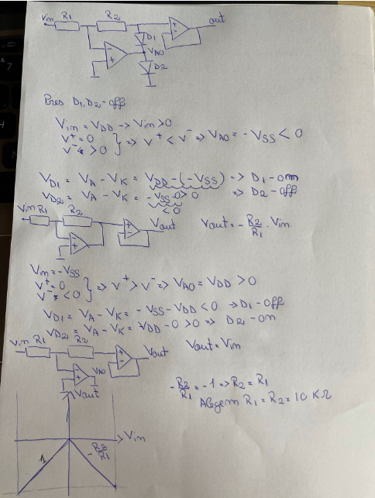

**DC/OP:**

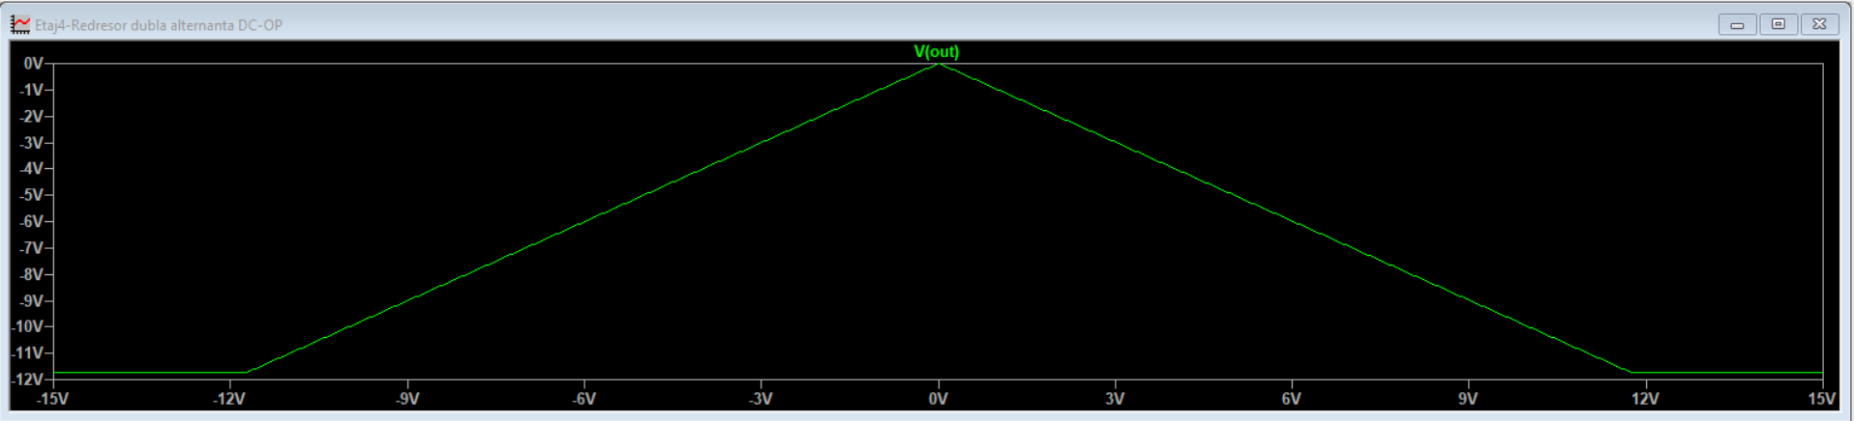

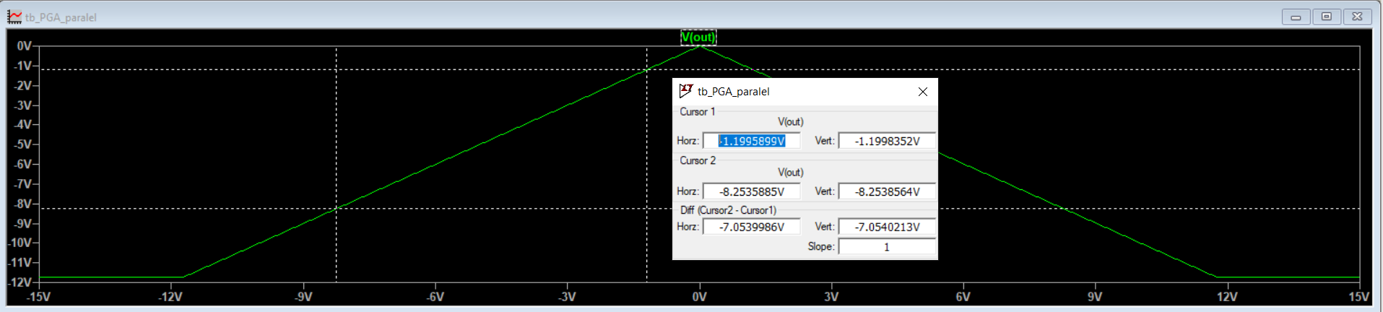

Panta este 1

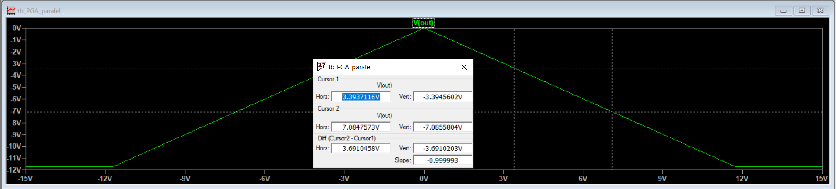

Panta este -1

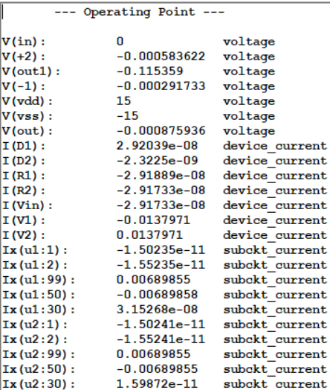

**AC:**

Castig linear=1 Castig db=0

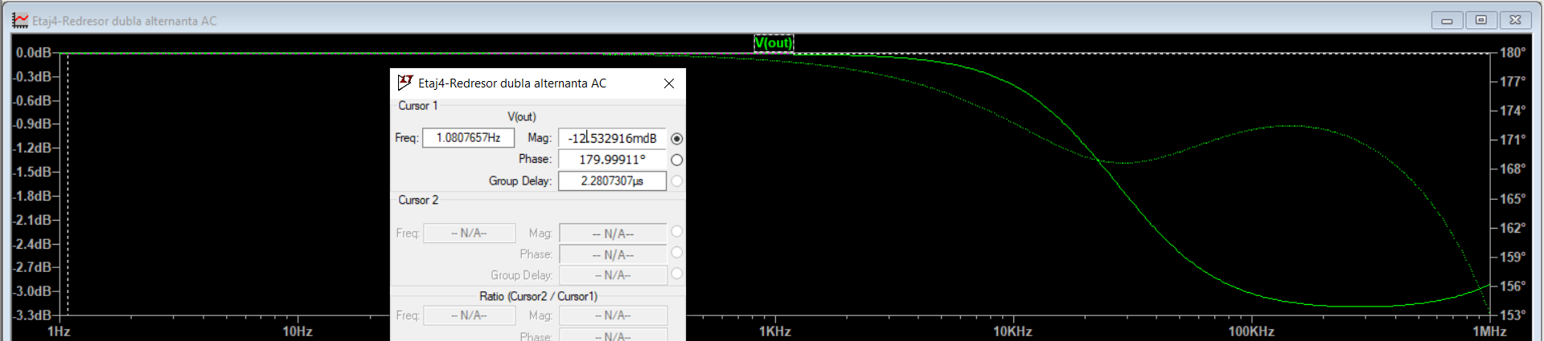

**TRAN:**

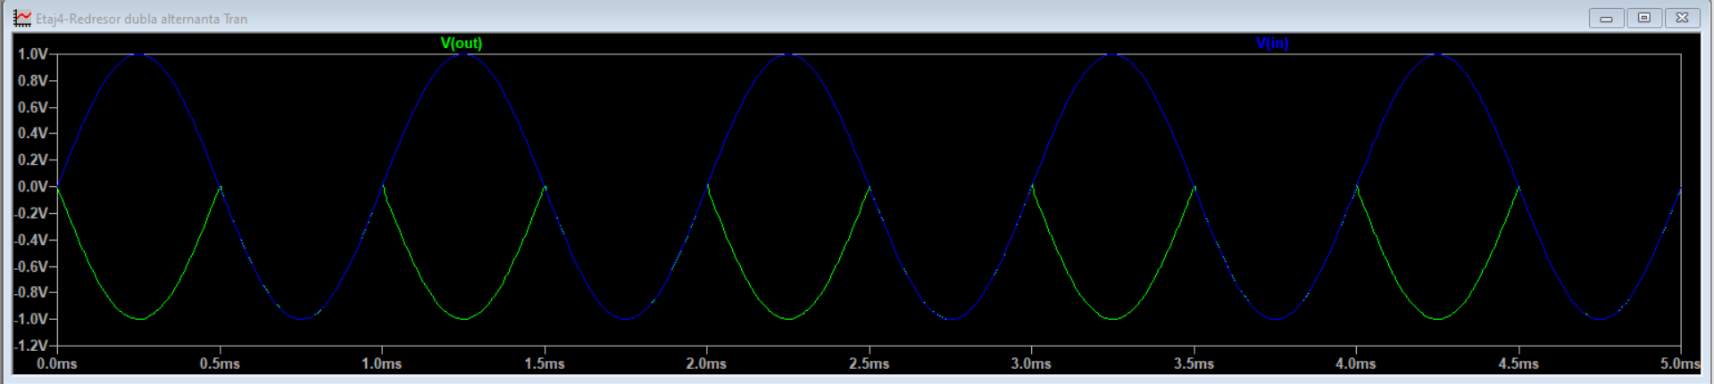

V_OA=V_saturatie=12V  
V_OA= -R2/R1*Vin- Vd= -Vin-Vd => Vin= V_OA- Vd= 12-0.6=11.4V

Vin=11.4V:

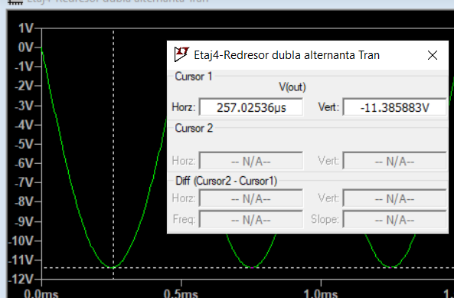

Vin=15V

